1) Run the database script from database folder.

2) change the databse connectionstring in web.config.

3) Run the web api project.

4) Use Postman/fiddler or other tools to call the service end point and observe the response.  
  
5) you can also use the public service url(http://106.51.133.113:8092/api/message)  
  
6) we have also attached the postman collection “RestService.postman_collection.json”  
  
  
  
  
**Test Screens :-1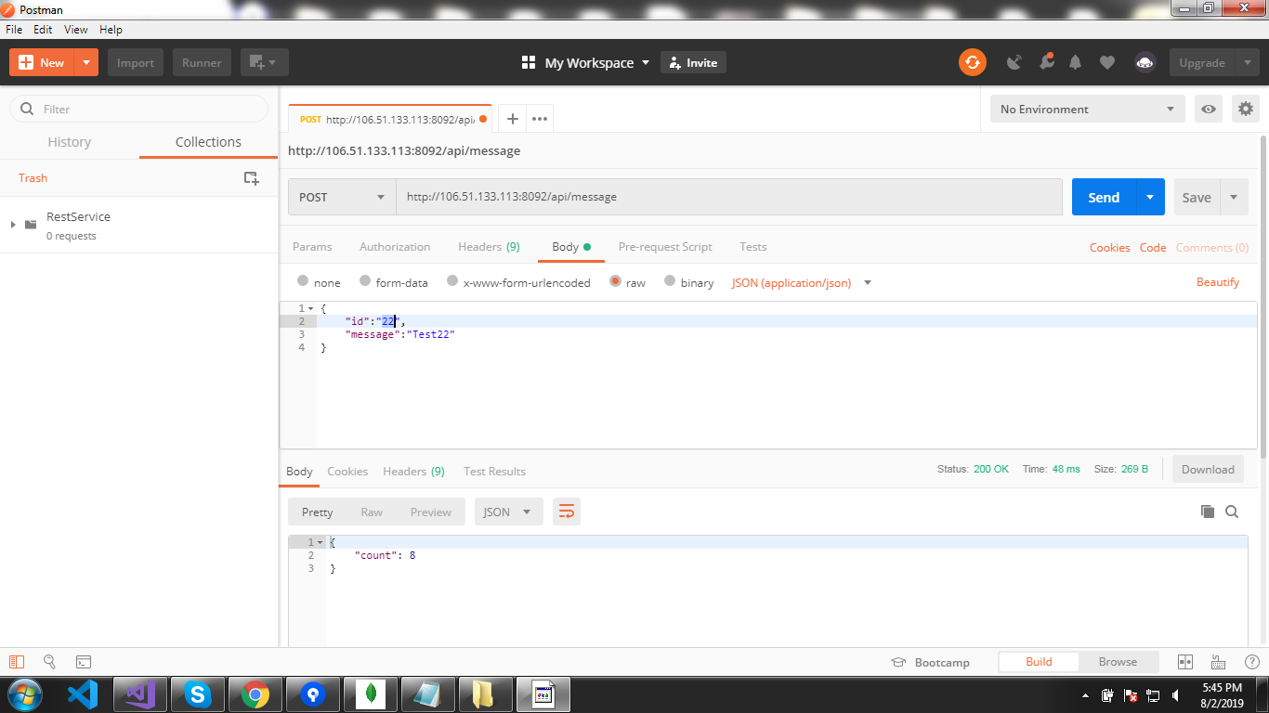 Test Screens :-2**